Vectors - Resultant Vectors and Components of a Vector

Use the parallelogram rule or head-to-tail rule to construct a resultant vector for each pair.
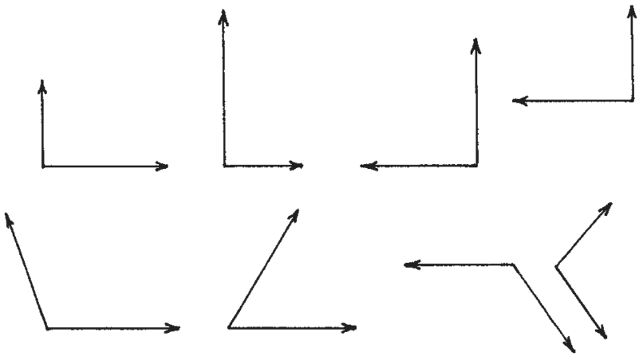

Construct the horizontal and vertical components of each vector below:

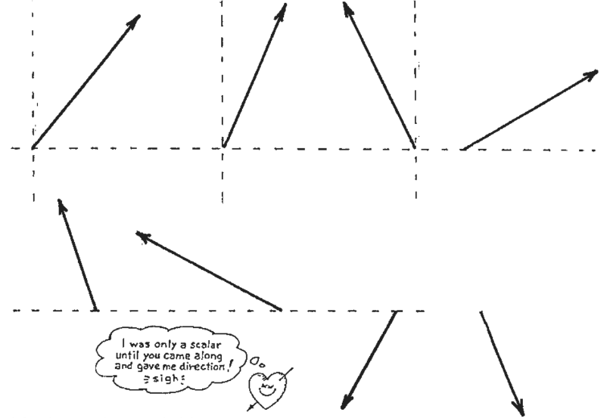

Toss Ball
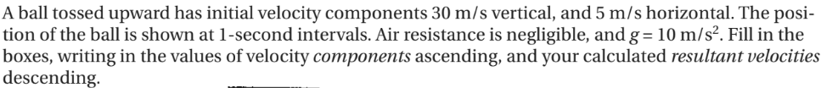

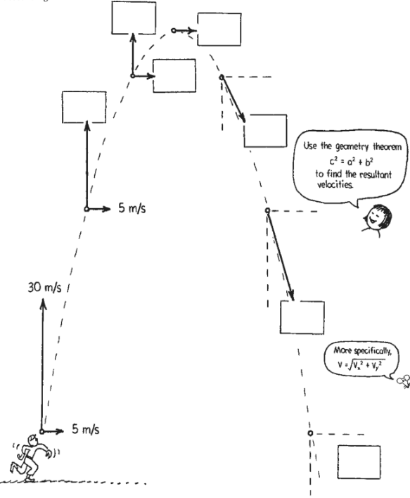
Horizontal Projectile
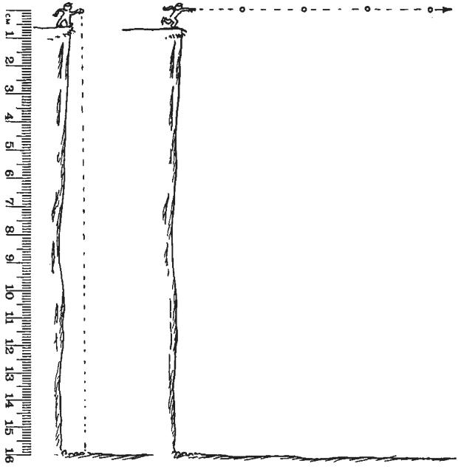
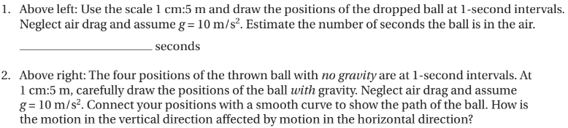
Answer:

Projectile Motion
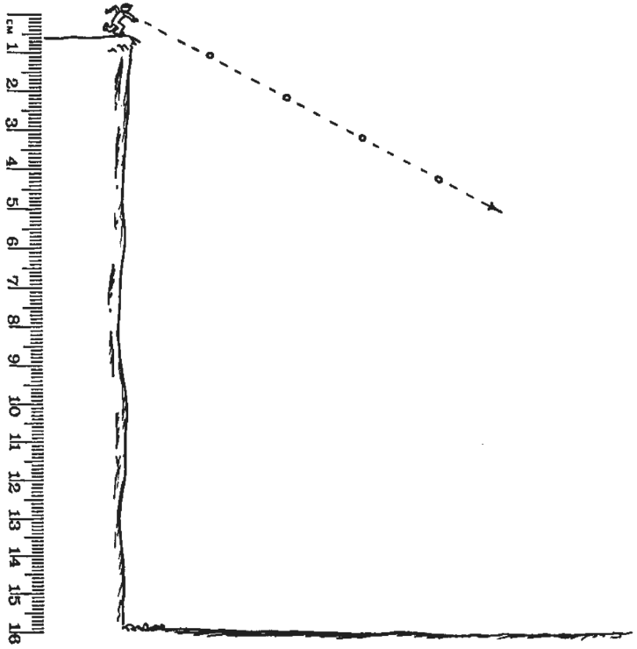
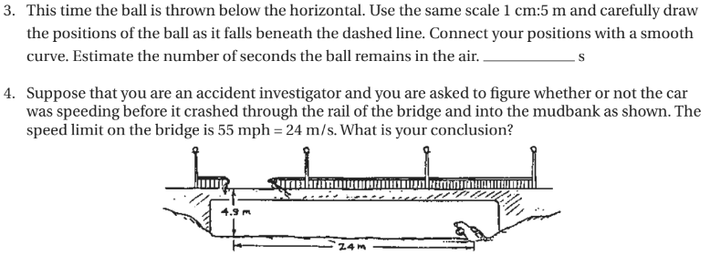
Answer:

Practice Problems
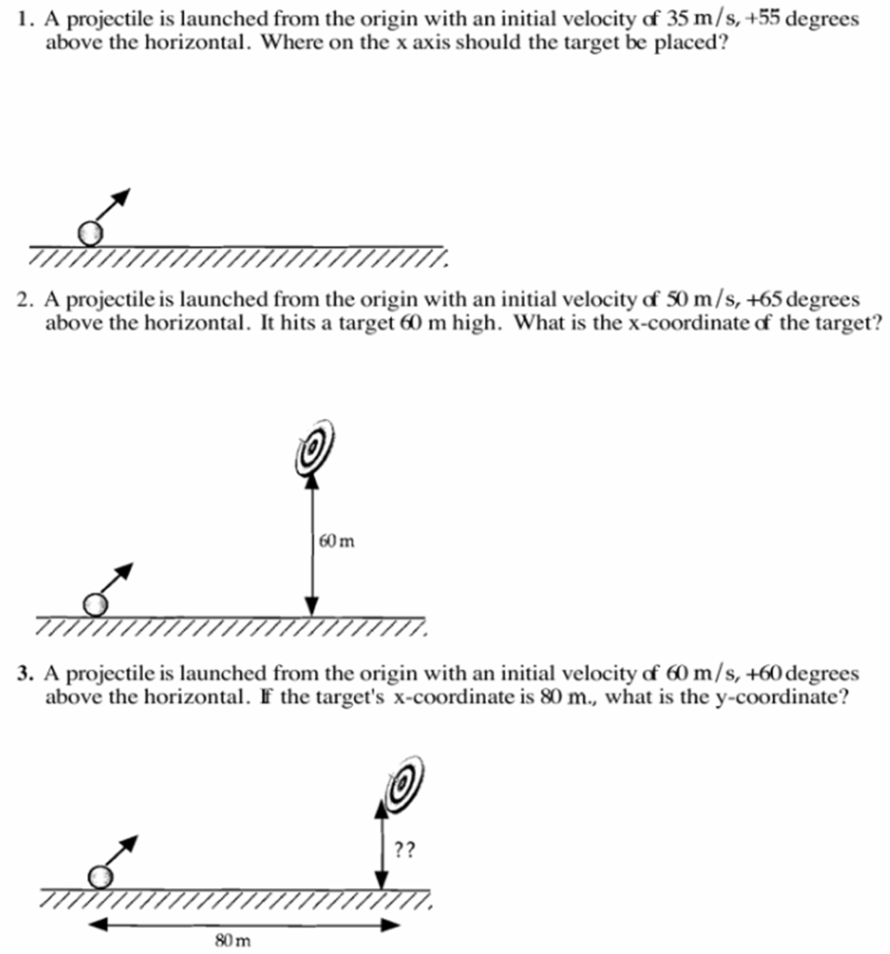

Sketch the a-t graph for the projectile above. Also sketch the v-t graphs for both Vx and Vy from 0-8s.

Optional Practice Problems:
